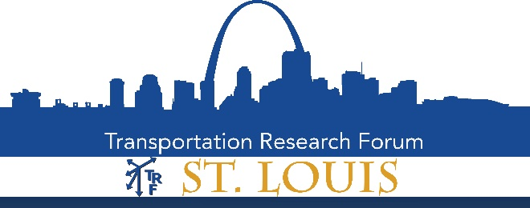

Dr. Nylen W. Edwards Memorial

Transportation Research Student Paper Contest

Sponsored by the Nylen W. Edwards Family and Lindenwood University

The Transportation Research Forum (TRF) - St. Louis Chapter is pleased to solicit outstanding student papers on current transportation issues at the local, state, regional and national level.

The honorarium is named after Dr. Nylen W. Edwards. Dr. Edwards taught Transportation at the University of Missouri – Columbia from 1953 through 1985. He directly influenced hundreds of students through his teaching and advising over the years.

Eligibility:
Papers must be written by a single author who is a currently enrolled undergraduate or graduate student at any institution of higher education within the St. Louis Chapter geographical area during the 2019/2020 academic year.

Requirements:
- Papers should provide contribution to the transportation industry, and be timely, interesting and important.
- Papers should include an introduction that thoroughly discusses the issue being addressed and demonstrates a good understanding of the topic.
- Papers must include a conclusion that contains managerial implications and recommendations.
- Papers are to be 2500-4000 words and include a 150 to 250 word abstract.
- Papers are to be double-spaced, with one-inch margins, 12 point type, Arial or Calibri font, and follow APA or Chicago style formatting.
- The title page should be a separate document and include the paper title, student’s name and email address.
- External sources must be used as support.

Awards:
The St. Louis TRF Board will evaluate papers based on a blind review. Current awards, subject to change, are outlined below.
- First Place - $350.00
- Runners-up - $100.00
- All award winners will receive a membership to TRF and an award certificate.

Submissions and Questions:
Submissions are due by May 10, 2020. Please direct your submission and questions to Mike Edwards at edwardsmg@umsl.edu
Founded in 1958, the Transportation Research Forum (TRF) is an independent organization of transportation professionals. Its purpose is to provide an impartial meeting ground for carriers, shippers, government officials, consultants, university researchers, suppliers, and others seeking an exchange of information and ideas related to both passenger and freight transportation. The Forum provides pertinent and timely information to those who conduct research and those who use and benefit from research. This exchange of information and ideas is accomplished through national and local TRF meetings, and by publication of professional papers.

