**A Framework Proposal for Assessing Berth Operational Safety in a Fuzzy Context**

**Johazwan, A.1, Salleh, N. H. M.2*, Rozar, N. M.2 & Sidik, H.3**

1Swift Integrated Logistics Sdn Bhd, 50470 Kuala Lumpur, Malaysia.  
2Faculty of Maritime Studies, Universiti Malaysia Terengganu, 21030 Kuala Nerus, Malaysia.

3Faculty of Entrepreneurship and Business, Universiti Malaysia Kelantan, Pengkalan Chepa, 16100 Kota Bharu, Kelantan.  
(johazwan.amir@swiftlogistis.com.my, [haqimin@umt.edu.my*](mailto:haqimin@umt.edu.my*), [norlinda.rozar@umt.edu.my](mailto:norlinda.rozar@umt.edu.my), hazeem.a18e031f@siswa.umk.edu.my)

*Corresponding Author

**ABSTRACT**  
Seaport operations are crucial activities to enable maritime trade between trading partners around the globe. However, these activities are prone to being risk oriented. Safety operation at seaport is the significant issue in the field of maritime safety. Providing safe environment during operation is one of the objectives by port authorities and operators to ensure safety level is at the highest. There are many accidents occurred every day in different part of all seaport in the world. Recently, accidents during berth operations are increase globally. Concerning about the issue, this paper carried out of safety risk assessment at berth operation covering berthing and unberthing operations, cargo loading and unloading operations, and berth yard transfer operations. The aim of this research is to identify and assess safety risk factors at seaport berth’s operation. To develop the assessment framework in a fuzzy context, an Analytical Hierarchy Process (AHP) and Evidential Reasoning (ER) approaches are used in this study. An AHP has been used in weighting the critical level of each risk factor. Then, the ER approach is proposed to deal with fuzzy assessment under high uncertain multiple-attribute decision making. In order to demonstrate the proposed assessment model, one of Malaysian seaport has been chosen as the test case. Based on the assessment, the result has shown that operational risks during cargo loading and unloading are the most concerned by port operators, followed by operational risks during berth to yard transfers and operational risks during berthing and unberthing. Trailers collision has been assessed the highest risk compared to other nine risk factors. This study is expected to assist port operators, port authorities and other related entities to enhance the safety awareness by implementing the fuzzy risk assessment on berth operation. As a result, mitigation strategies can be implemented to reduce the assessed risk level to minimum as possible.

**KEYWORDS:** Seaport, safety, risk, container terminal, berth operation, fuzzy.

**1. INTRODUCTION**

Seaport industry plays a key role in nation’s growth and development (Rozar et al., 2018; Cho et al., 2018; Pallis, 2017; Bauk et al., 2016; Barbra and Casal, 2004). It is a fact that around 90% of the world trade is conducted by sea (by volume) and 60% by value and sea transport remains the most economical way to mass transportation of goods worldwide (Rozar et al., 2018; John et al., 2016; IMO, 2015). 95 % of foreign trade and 25 % of domestic trade in United States dependant on the sea and maritime (Merrick and Dorp, 2006). The world economy is heavily dependent upon the operation of these systems, which leads to high systemic complexity and could lead to a terrible and catastrophic impact at any time in their operation (John et al., 2016). To boot, the operational risks associated with seaports are dangerous places for port workers and pedestrians such as (un)loading, management and transport of port traffic, handle equipment, warehousing, etc. In all conditions, seaports normally operate 24 hours a day with diverse workers and contractors performing various activities (Roberts and Gray, 2013). This is supported by Darbra and Casal (2004) that narrated workers in seaports tend to be related to soil and water contamination, problems with dust and noise issues, waste production, dredging activities, transportation of boats, trucks and trains, storage of dangerous substances in warehouses etc. Given the properties and the operations; the possibilities of an accident are scarcely negligible (Planas-Cuchi, 1997).

Henceforth, safety has become the most significant and vital issue especially in maritime transportation industries (Corrigan et al., 2018; Chang et al., 2014; Darbra and Casal, 2004). It links with the well-being of people and other activities in workplace (Chlomoudis and Tzannatos, 2016). Any accident will significantly affect the operations leading to damage to property or environment, even people injury and casualty. Moreover, accident will affect the port performance, for instance service delay, deviation, stoppage and loss of service platform. This is supported by Rozar et al. (2018) that efficiency is a priority in port operation and the main agenda for improving terminal efficiency is to reduce anchorage, berthing and stockpiling time. Since the berth area is the frontal area for mooring vessel, the necessity of safe operations in this area needs to be highlighted. John et al. (2016) and John et al. (2014) added that given the importance of developing the port system coherent with the globalisation; it is difficult for decision-makers to maintain a balance between health, safety, security, sustainable management and systems resilience, in the face of various operational uncertainties which result in system breakdowns. In other words, safety and health always become a hindrance in developing a new system. Aside from that, occasional accident in seaport would exert negative image to the port, with a potential creation of a sense of rejection among the population as it would negatively affect the nation economy and stakeholders (Trbojevic, 2000; Planas-Cuchi, 1998). The employer has the obligation to safeguard workers’ health and safety and improve their safety in the workplace. Yet, the inconvenient truth is that tragedy and accidents in seaports is not an uncommon incident (Darbra and Casal 2004). The increasing number of accidents is directly related to the increase of turnover in the past decade in the seaport. People tends to leave their workplace due to bad working environments which lead to their dissatisfaction and lead to turnover intention and they really would leave (Sidik et al., 2017).

Apart from that, in a more develop seaports, safety should be in favour of employees as there is relatively low turnover; although, there are no official statistical data on this issue (Bauk et al., 2018). However, it is a must to enhance security measures without gambling and wagering on people’s lives. This is because 80% of maritime accidents worldwide are caused by human and organizational factors (Corrigan et al., 2018). In an evidence shown by Pak et al. (2015) in Korea, there are 882 maritime accidents and one over fifth of it is from seaport. Unfortunately, it has been perceived in most of seaports that they do not even have contemporary safety solutions gazetted in the port operation. There were already 471 cases of accidents with 12,844 records in the beginning of twentieth century only. The results show a significant increase in the rate of injuries over time: 83% in the last 20 years and 59% in the last 10 years. Fire (29 percent), explosion (17 percent), and gaseous clouds (3 percent) were the most common incidents in seaports (Darbra and Casal, 2004).

Security experts unanimously believe human element would be the main disruption in applying a new system in seaports and thus need to be tackled first (Corrigan et al., 2018; John et al., 2014). Between 1980 and 2002, the analysis of Darbra and Casal (2004) analysed worldwide data from the Major Incident and Risk Inventory (MHIDA). It has shown that almost 60% of incidents include ship manoeuvrability and freight transport in ports, by truck and rail. In addition, cargo loading, and uploading are associated with about 15% accidents, cargo distribution and stores 12%, plant processes 11% and storage 4%. Yip (2008) also demonstrated clearly that collisions are the most frequent form of ports incident and accident. One cause of those incidents is the heavy traffic and congestion which large ports must cope with (Antão, 2016).

There are variety of international legal instruments such as the ISM Code (the International Safety Management Code), and the ISPS Code (the International Ship and Port Facility Security Code). These have been adopted by International Maritime Organization (IMO) in order to solve and resolve the safety issue in maritime (IMO, 2010; 2012). Still, the danger to maritime safety and health is still high as shown by the regular occurrence of incidents of maritime safety and security and the tremendous losses in most cases (Chang et al, 2014). In parallel, academicians and industry also recognize that their efforts to mitigate risks for safety and security always achieve low returns (John et al., 2016). Additionally, there are studies that have been performed from different perspectives to tackle maritime health and safety issues such as human aspect factor (Lu and Tsai, 2008; 2010), innovation (Bauk et al., 2015; Bauk et al., 2016) and technological factors (Kim et al., 2013). Still, there is very little attention given to port safety and health (Antão et al., 2016). In addition, Tadic et al. (2017) narrated that it is a fact that no research papers deal with seaports as part of the processes approach. The analyses of port incidents and the port safety factor are based mainly on a review of historical accident statistics (Jalonen and Salmi, 2009; Kujala, 2009; Darbra and Casal, 2004; Christou, 1999) and safety improvement factors in maritime (Trbojevic and Carr, 2000). Therefore, an evaluation of the results and improvement of port safety processes need to be achieved.

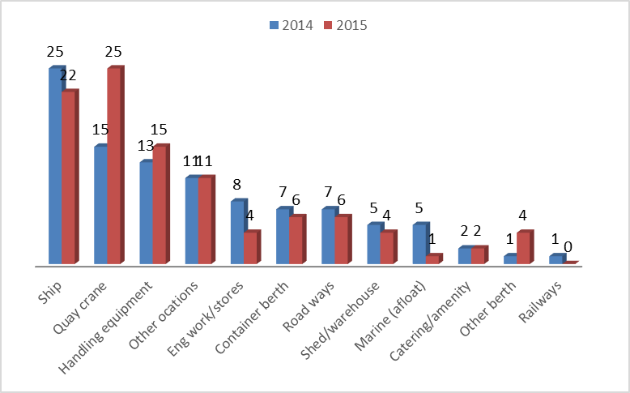

**Figure 1: Total accidental events by locations in 2014 and 2015**

Source: Port Skill and Safety (2015)

Therefore, there is a need for this study to be done in order to ensure the safety and health of workers in seaports. Figure 1 shows the total case of accident events in 2014 and 2015. This figure highlighted the top named locations for accidents in seaport where quay crane has increased from 15% in 2014 increase to 25% in 2015. Besides that, ship locations fall from 25% to 22% and cargo handling equipment rose from 13% to 15%. The top three accidents were mentioned are occurred in berth areas. This is supported by Chang et al. (2014) that found the top hazard factors for safety and security damage associated with physical flow in port are quay damage caused by inappropriate berth operations, and damage from dangerous goods transportation. Particularly, those are involving with asset loss and damage especially within berth area. That is why there is rules and regulation in order to guarantee optimal management especially involving dangerous goods (Rekik et al., 2015). Concerning about the issues, this paper attempts to carry out the investigation on berth operational hazards by assessing it by using a new framework proposal. To boot, operational hazard study is closely related and linked towards seaport safety and health as the result of the study will be used to improve and enhance the safety of seaport (Pak et al., 2015).

The primary aim of this paper is to propose a new assessment framework for identifying, assessing and suggesting strategies for minimizing berth operational hazards in seaport. This study concentrates on the hazard involved in berth operations and seeks to extend the research through more comprehensive and inclusive approach to this issue. Thus, this study will focus on safety on berth operations (i.e. berthing and unberthing operations, cargo loading and unloading operations and berth to yard transferring operations). Further, this study also pointed out regarding several factors which may be considered as hazards, and every factor will be assessed. In order to assess the identified risk factors and hazards under high uncertainty, Analytical Hierarchy Process (AHP), and Evidential Reasoning (ER) approaches will be applied in this assessment. By considering the nature of seaport data is limited to reach, fuzzy environment will be considered where the assessment process will involve few fuzzy approaches. The findings of this journal will identify key risk sources and provide useful information to establish safer operating procedures and contingency plans.

**2. LITERATURE REVIEW**

In the new era of globalization, safety operations at port is the significant issues in field of maritime safety. Safety issues are the main central cases that have been facing by the port authorities. Providing safe environment during operation is one of the objectives by port authority to ensure safety. In context of shipping industry, there are many accidents happened every day in different part of all port in the world (Navarackas, 2017; Trbojevic and Carr, 2000). Hence, safety issues are the crucial in port and need to consider by the port authority in order to provide safe environment among workers.Branch (2012) in his book elements of port operation and management claimed that, port as a point through which goods and passengers pass. In other words, port indirectly as a link in a transportation chain connected by multimodal transportation including rail, sea and road. In context of port safety, extensive and legislation exists in the provision of port operation (i.e. health and safety aspects, equipment maintenance).

Safety in port is most important in ensuring operational smoothly thus, attracting more research relates to the risk like from operational, organizational and economic perspectives (Alyami et al., 2014: Legato and Monaco, 2004; Marlow and Casaca, 2003; Mokhtari et al., 2011). Further, International Maritime Organization (IMO) is one of the agencies that established in order to improving the quality of safety in maritime industry. The purpose of this agency is to promotion of the implementation of the international standards and regulations for the improvement of maritime safety (Kontovas, 2005). In year 1993, IMO makes the decision making and new regulations proposed by the United Kingdom Marine Safety Agency that Formal Safety Assessment (FSA) should be applied in shipping industry to ensure the effectiveness of safety during operation (Trbojevic, 2001; Tseng and Pilcher, 2012). The extensive literature of safety in maritime industry has been finding out on the Table 1.

**Table 1: Summary of the Previous Research on Safety in Maritime Industry.**

|  |  |
| --- | --- |
| **Authors** | **Research Information** |
| Smith (2003) | The model explained the analysis of factors that may led to reduce the safety. |
| Darbra and Casal (2004) | The research analysed various causes of the accidents (cause, substances involved, and consequences) and provide a safety measure and plant in order for safety improvement in seaport industry. |
| Cho et al. (2010) | The model illustrates the relation between project lifecycle and safety improvements and explained potential hazards for port development. |
| Hänninen et al. (2014) | This model emphasizes to the Port State Control Inspection, and this model could be applied for maritime safety related decision making. |
| Chang et al. (2014) | The study identified and analysed the risks that may cause maritime safety and security damage and elucidated on risk response strategies in shipping container operation |
| Rekik et al. (2015) | This study is on safe Stacking System for dangerous containers in seaport terminals |
| John et al. (2016) | The study proposed a modelling of a maritime port system using Bayesian beliefs networks with risk analysis to create a resilience maritime system |
| Antão et al. (2016) | The study of safety indicators implementation in ports that assess the performance and track trends over time on Occupational Health, Safety and Security issues |
| Park et al. (2016), Pak et al. (2015) | The proposed methodology can be used for assessing the hazards to the port safety. |
| Alyami et al. (2016), Pallis (2017) | This model proposed the analysis the specific risk estimation and their risk influence on a port safety system. |
| Bauk et al. (2015), Bauk et al. (2016) | This model proposed using innovation such as Radio Frequency Identification (RFID), Radar system, Anti Collison system and Closed-Circuit Television (CCTV) in order to improve safety at seaport. |
| Hamka (2017) | The study used Fault Tree Analysis Methods in investigating the root of cause of the highest risk activity in port |
| Corriingan et al. (2018) | The study adopted a multimethod logical approach including the completion of a port-wide safety culture assessment study. |
| Cho et al. (2018) | The study developed a model based on theoretical foundations and empirical findings of maritime risk involved and assessment in seaport operation. |

Compiled by Authors

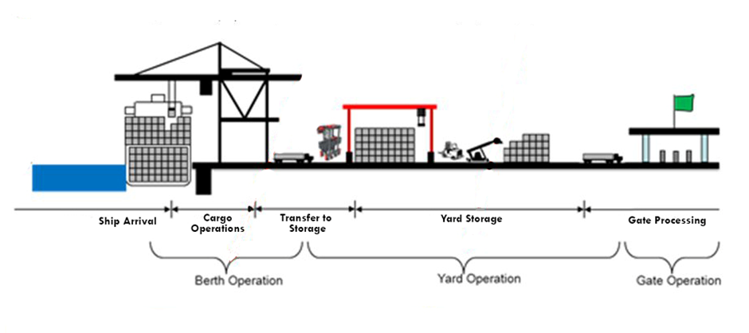

**Figure 2: Identical Scope of berth operations at Container Terminal.**

This study will be focusing on berth operations (Figure 2) which involved three significant safety risks (i.e. berthing and unberthing operational risks, cargo loading and unloading operational risks and berth to yard transferring operational risks). In order to assess risk factors, nine factors have been identified from the review of several literatures, which are ship to berth collision, ship to ship collision, ship grounding, container slipped, container lock fell down, quay cranes overloading, trailer hit trailer, trailer hit worker and trailer hit handling equipment.

In practice, the ship factor comprises ship staff and condition of berthing equipment. As claimed by Lu and Tsai (2008), these include ship crews related safety practices, safety training includes operational skills and work attitudes in cooperating with the marine pilot. Apart from that, condition of berthing equipment consists the steering and windlasses. In recent literature review found that, equipment failure may contribute to this risk occurred during berthing activities (Darbra et al., 2006). Traffics conflicts in port may cause collision between ship occurred during berthing and unberthing process. The number of traffic movements in ports can be up to 2000 per day, therefore, it will be contributed to the collision between ships due to heavy condition in berth area (Yip, 2008). According to Murdoch et al., (2012) stated that, almost 70% accidents in port with more involve in dock damages caused by ship control and tugboat failure. Mazaheri et al., (2015), ships grounding accidents occurred due to alarm missing or not clear. He claimed that, when dangerous situation happen, alarm on board are not performed or the alarm is not fully function and clear to make them aware while danger situation. Based on the study carried out by Ugurlu et al., (2015) found that, in 1993 until 2011 the factors which may contribute to the ship grounding includes lack of communication, lookout errors, interpretation errors, use of improper charts, inefficient use of bridge navigation equipment and fatigue.

The risks dimension related to machine or equipment failures such as quay crane while perform this operation (Ding and Tseng, 2012). In the most recent literature review found that the top accident risks in terms of severity which are, the gantry crane did not lift the boom to move facilities caused damage to the pilot's compartment and slipped the containers to the trailers directly (Shang and Tseng, 2010). As stated by Shang and Tseng (2010) container lock fell down causes hanger of the quay crane damaged by human errors. In his study also maintained that, human factor in loading and unloading operations risks are the major causes of this accidents. In addition, he indicated that about 25% of the total accidents in container terminal involving human negligence. The communication problems arise from misapprehension when message or information among workers are not clear or understood and when this situation happens, risk of accidents might be increased (Ding and Tseng, 2012; Fadda et al., 2015).According to Occupational Safety and Health Administration (OSHA), 80% of all cranes upset and structural failures can be attributed to exceeding the crane operational capacity. When a crane is overloaded, it is subject to structural stresses that may cause irreversible damage. Nearly, 80 % of these upsets can be attributed to predictable human error when the operator inadvertently exceeds the quay crane lifting capacity (Spanco, 2014).

Hakkanen and Sumalla (2001) stated that, causality factors, the responsibility of the driver and driver fatigue related factors were studied in fatal two-vehicle accidents during the period of 1991 to 1997. The result of the study found that, fatigue in professional truck drivers is one of the significant causes which may contribute to this event. Mansor *et al.,* (2011) there was a positive relationship between job stress and accidents. They also claim that, link between stresses which may be involved in motor vehicle accident like trailer. Norris *et al.,* (2000) maintained that, stress behaviour may reducing the safety while driving and it has potential to contribute the accident occurred. In accordance to Commission for Occupational Safety and Health (2006), people who work with, or near vehicles and mobile plant, such as trailers are categories in risk situation. It causes by vehicles and pedestrians does not clear segregated and sign posted walkways are not provided. Recent previous research has been conducted by Mansor *et al.,* (2011), human error that may potentially cause to the accident. Unsafe acts can be classified as a human error which the action that departs from hazard control or job procedures. According to Health and Safety Authority (2015) and Commission for Occupational Safety and Health (2006) stated that, inappropriate traffic management system in port may contribute to trailer hit the handling equipment like quay crane in port and the majority of accidents in port due to poor design and layout of workplaces.

For assessing the safety risks factors, two methods are used including Analytical Hierarchical Process (AHP) and Evidential Reasoning (ER). AHP approach is an effective tool for dealing with complex decision making with the weighting the importance factors and make the best decision (Kwong and Bhai, 2001 and Salleh, 2015). It uses a multi-level hierarchical including main criteria, sub-criteria and alternatives. In addition, AHP approach using pairwise comparisons in order to reducing complex decision. Therefore, the purpose of this approach is to consider the consistency of the decision makers thus, reducing the bias in the decision-making process. Based on multilevel evaluation of factors model, an ER approach has been developed in order to supporting each decision analysis. Basically, ER approach has developed to enhance the process of aggregating attributes with uncertainty (Yang and Xu, 2002).

**3. FRAMEWORK METHODOLOGY**

In order to assess the safety risk factors on berth operation at Port “A”, different decision-making methods are used such as Analytical Hierarchy Process (AHP) and Evidential Reasoning (ER). Furthermore, to develop the calculation process of the safety risks factors model, a flow chart of proposed methodology has been developed as illustrated in Figure 3 and describe how the steps of methodology framework in order to achieve the objectives.

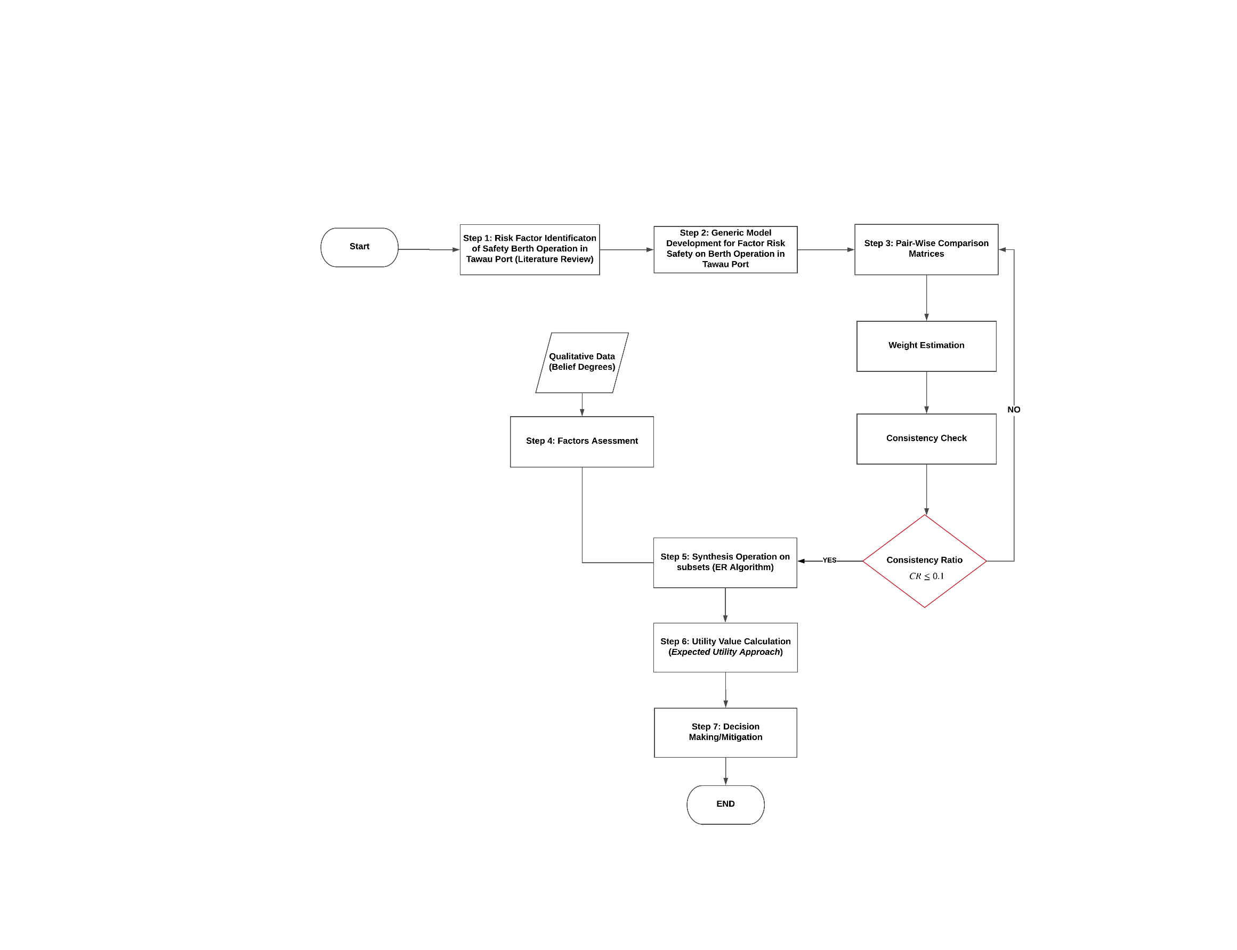 **Figure 3: The Flowchart of the Assessment Framework**

*3.1 Risk Factor Identification of Safety Factor at Berth Operation (Step 1)*

The identification process of risk factors in this paper is based on the literature review by listing each risk factors, and then classifying them into appropriate criteria. Every significant factor related with the safety issue is carefully reviewed. The main criterion of these factors was divided into three which are, berthing and unberthing process, cargo loading and unloading operations and berth to yard transferring operation. Further explanation related the main criteria and sub-criteria were discussed in literature review.

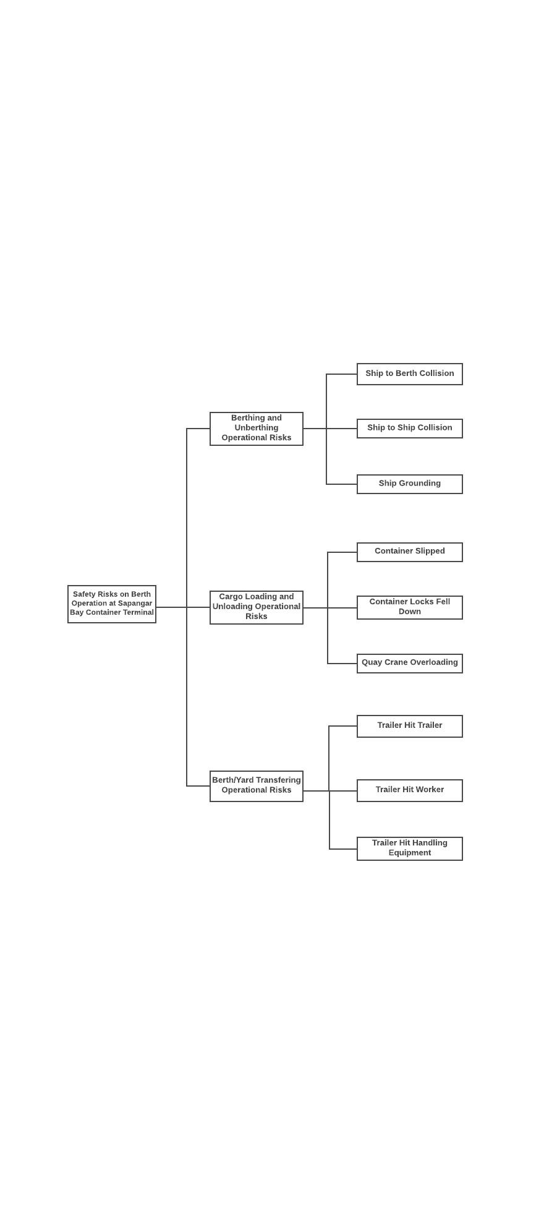

**Figure 4: Generic Model for Safety Risk Factor**

*3.2 Development of a Generic Model for Safety Risk Factor (Step 2)*

In this step, developing a generic model in this study is that it can be modified or adjusted to be used for a particular firm or industry. Generic model as shown in Figure 4 are based on the factors as has been listed in Step 1. Based on Figure 4, Safety Risk Factor (i.e. Goal) is determined by three main criteria (i.e. berthing and unberthing operational risks, cargo loading and unloading operational risks and berth to yard operational risks). Berthing and unberthing operational risks consist three sub-criteria (i.e. ship to berth collision, ship to ship collision and ship grounding), cargo loading and unloading operational risks (i.e. container slipped, container lock fell down and quay crane overloading), berth to yard transferring operational risks (i.e. trailer hit worker, trailer hit trailer and trailer hit handling equipment).

*3.3 AHP Weight Assessment (Step 3)*

Step 3 discussed or elaborate on how to assign each criterion based on pair-wise comparison (i.e. AHP). Fundamental scale of absolute number is used in pair-wise comparisons in order to compare the alternatives or criteria. Table 2 shows a preferable scale from 1 to 9. In this table, the comparison scale described by using linguistic meaning where scale 1 as the equivalent between the factors, scale 3 refers as weekly important, 5 is strongly important, 7 very strongly important and extremely important for 9. However, 2,4,6,8 are intermediate values between two adjacent judgments. To avoid misjudgement, each expert should understand the ratio scale of pair-wise comparison before making the assessment.

**Table 2: Comparison Scale**

|  |  |
| --- | --- |
| **Numerical Assessment (Scale)** | **Linguistic Meaning** |
| 1 | Equally Important (EQ) |
| 3 | Weekly Important (WE) |
| 5 | Strongly Important (ST) |
| 7 | Very Strongly Important (VS) |
| 9 | Extremely Important (EX) |
| 2, 4, 6, 8 | Intermediate values between the two adjacent judgments. |

To determine the consideration pair of criteria $A_{i}$ and $A_{j}$ are presented by an n × n matrix D. The $a_{ij}$ entries are defined by entry rules as follows:

* Rule 1: if $a_{ij}$ = $α,1/α,α≠0$
* Rule 2: if $A_{i}$ is judged to be of equal number of equal relative number as $A_{j}$, then $a_{ij}$ = $a_{ji}$ = 1.

According to above rules of matrix D is shown as follows:

(1)

$$D=a_{ij}=\left[\begin{matrix}1 & a_{n} ⋯ & a_{1n} \\ 1/{a_{n}} & 1 ⋯ & a_{2n} \\ 1/{a_{1n}} & 1/{a_{2n}⋯} & 1\end{matrix}\right]$$

where*i, j* = 1, 2…., *n* and each $a_{ij}$ is the relative importance of criterion $A_{i}$ to criterion $A_{j}$.

The quantified judgement of comparison on pair (Ai, Aj) is noted as *aij* in the matrix D; a further step is to derive weight vector for each criterion or alternative, as it show the prioritization of the criterion or alternatives (Salleh et al., 2015) a weight value *wk* can be calculated as follow:

(2)

$$wk= \frac{1}{n}\sum_{j=1}^{n}{\left(\frac{akj}{\sum_{j=1}^{n}{a_{ij}}}\right)}k=1,2,3,….,n$$

where $a_{ij}$ stands for the entry row*i* and column *j* in a comparison matrix of order *n.*

By using Consistency Ratio (CR), inconsistency of pair wise comparison can be measured. If CR value is 0.10 or less, the consistency of the pair wise comparison is considered reasonable and can be accepted, the AHP continue with calculation of weight vector (Salleh et al., 2015). However, if CR is greater than 0.10 it will lead to an inconsistency of pair wise judgements. Thus, decision maker shall review the pair wise judgement before proceeding. To check the consistency of judgements, a CR is computed by using equation 3-5.

$$CR= \frac{CI}{RI}$$

(3)

$$CI= \frac{λ max-n}{n-1}$$

(4)

$$λ\max{= }\frac{\sum_{j=1}^{n}{\left(\frac{\sum_{k=1}^{n}{wk ajk}}{wj}\right)}}{n}$$

(5)

where CI is the inconsistency index, RI is the average random index (Table 3), *n* is the number of items being compared, and $ℷ_{max}$ is the minimum weight value of the *n × n* comparison matrix D (Salleh *et al*., 2015).

**Table 3: Value of Average Random Index**

|  |  |  |  |  |  |  |  |  |  |  |
| --- | --- | --- | --- | --- | --- | --- | --- | --- | --- | --- |
| **n** | 1 | 2 | 3 | 4 | 5 | 6 | 7 | 8 | 9 | 10 |
| **RI** | 0 | 0 | 058 | 0.9 | 1.12 | 1.24 | 1.32 | 1.41 | 1.45 | 1.49 |

*3.4 Qualitative Risk Assessment (Step 4)*

There are various methods of qualitative data collection and one of them is through domain expert judgements. A qualitative criterion can be presented by linguistic variables (i.e. linguistic terms and their corresponding belief degrees). According to Salleh et al., (2014; 2018) presented that, the number of remarkable coincidences between the channel capacity of several human cognitive and perceptual tasks. They also indicated the effective channel capacity between five equally weighted errorless choices. In this framework, five assessment grades (i.e. very low, low, medium, high and very high) were assigned to all main criteria while three parameters (i.e. severity, frequency and resilience) are used to assess sub-criteria. The assessment grades for severity of each sub-criteria are negligible, marginal, moderate, severe and catastrophic; frequency will be assessed by using high unlikely, unlikely, possible, likely and very likely; and resilience will be assessed by using very high resilience, high resilience, moderate resilience, low resilience and very low resilience. This assessment grades is demonstrated in Table 4 as follows:

**Table 4: Assessment Grades of Safety Risk Factors**

|  |  |  |  |  |  |  |
| --- | --- | --- | --- | --- | --- | --- |
| **Factors** | | **Assessment Grades** | | | | |
| **Main Risk Factors**  **Safety Risk Factor** | | Very Low | Low | Medium | High | Very High |
| **Sub-Risk Factors** | **Severity** | Negligible | Marginal | Moderate | Severe | Catastrophic |
| **Frequency** | High Unlikely | Unlikely | Possible | Likely | Very Likely |
| **Resilience** | Very High Resilience | High Resilience | Moderate Resilience | Low Resilience | Very Low Resilience |

The specific measurement for each assessment grade will be demonstrate in test case. These assessment grades will be synthesized after gathering the assessment from experts. This synthesis will be conducted using ER Algorithms (Yang and Xu, 2002; Salleh et al., 2014).

*3.5 Synthesis Operations on Subsets by Using ER Algorithms and Utility Value Calculation (Steps 5 and 6)*

The basis of a multi-attribute evaluation framework and the evidence combination of the D-S theory has led to the development of ER Algorithm (Yang and Xu, 2002; Salleh et al., 2014). ER Algorithm is where an upper level is assessed through lower level attribute association and it helps to aggregate multi-attributes in a hierarchical structure (Salleh et al., 2014). Further explanation of ER Algorithms can be referred to (Salleh et al., 2014). In this study, this effectiveness evaluation will be computerized using Intelligent Decision System (IDS) only. The results from factor assessment will be presented by five linguistic terms (i.e. very low, low, medium, high and very high). Utility value is used to obtain a single value for decision makers to rank on the alternatives available and further make comparison between alternatives (Equations 6-7).

(6)

$$u\left(H_{n}= \frac{V_{n}-V_{min}}{V_{max}-V_{min}}\right)$$

(7)

$U_{v}=\sum{\begin{aligned}N \\ n\end{aligned}}β_{n}^{U}(H_{n})$

**4. TEST CASE: PORT “A"**

In order to demonstrate the applicability of the assessment framework, one of Malaysian seaport named as Port “A” has been chosen as a case study. For the assessment process of the Safety Risks Factors Model, a decision-maker has to deal with qualitative data. To deal with qualitative data, 20 experts in the Port “A” are approached to perform the pair-wise comparison for every risk factor. The selection of domain experts for their judgements was based on their position and experiences as shown in Table 4. In this study, the experts must have more than five years’ experience. The methods of collected the data through interview session.

**Table 4: Experts’ knowledge and experience**

|  |  |  |
| --- | --- | --- |
| Experts | Position | Experiences |
| 1 | Health and Safety Environment Officer | 18 years |
| 2 | Quay Crane Operators | 15 years |
| 3 | Mechanical Executive | 20 years |
| 4 | DHUR Staff | 15 years |
| 5 | Senior Marine Officer | 14 years |
| 6 | CTTR Instrumentation Technician | 15 years |
| 7 | Operation Assistant Manager | 10 years |
| 8 | Prime Mover Driver | 10 years |
| 9 | Mechanical Executive | 17 years |
| 10 | Human Resources Operations Officer | 8 years |
| 11 | Security Assistant | 12 years |
| 12 | Assistant Security Officer | 17 years |
| 13 | Marine Officer | 19 years |
| 14 | Assistant Security Officer | 15 years |
| 15 | GR Operator | 12 years |
| 16 | Prime Mover Operator | 15 years |
| 17 | Senior Surveyor | 11 years |
| 18 | Assistant Manager Health and Safety Environment | 10 years |
| 19 | Equipment Operator | 11 years |
| 20 | Executive Human Resources Operation | 15 years |

The generic model as shown in Figure 4 can be modified to be used for a firm or industry. In the test case, there are no factors have been removing from the model. As shown in Table 5, three main criteria and nine sub-criteria are selected.

**Table 5:** Summary of Revised Factors for Assessing the Risk Factors

|  |  |
| --- | --- |
| Main Criteria | Sub-Criteria |
| Berthing and Unberthing Operational Risks | Ship to Berth Collision, Ship to Ship Collision, Ship Grounding |
| Cargo Loading and Unloading Operational Risks | Container Slipped, Container Lock Fell Down, Quay Crane Overloading |
| Berth to Yard Transferring Operational Risks | Trailer Hit Worker, Trailer Hit Trailer, Trailer Hit Handling Equipment |

By using pair-wise comparisons to assign a weigh of each criterion, an AHP method are used in this study. It was mentioning that, 20 selection experts at Port “A” and each expert have their own criteria (i.e. position and experience) before they make the assessment. Analytical Hierarchy Process (AHP) has been used to find weight value of the expert’s judgment for each risk factor (i.e. berthing and unberthing operational risks, cargo loading and unloading operational risks and berth to yard transferring operational risks) and tested with Consistency Ratio (CR) to prove the validity of the expert’s judgment as shown in Table 6. Once judgment have been entered, it is necessary to check that they are consistent. To know the CR data is valid, the value should less than or equal 0.10.

**Table 6: Result of Weight Values and Consistency Ratios for all Main and Sub-Criteria in the Safety Risk Factor Model**

|  |  |  |  |  |  |  |
| --- | --- | --- | --- | --- | --- | --- |
| Goal | Main Criteria | Weight | Sub-criteria | Local Weights | Global  Weights |  |
| Safety Risk Factors | Berthing and Unberthing Operational Risks | 0.2513 | Ship to Berth Collision    Ship to Ship  Collision  Ship grounding  ***CR =*** | 0.3737  0.3264  0.3000  0.0031 | 0.0939  0.0820  0.0754 |  |
|  | Cargo Loading and Loading Operational Risks | 0.4409 | Container Slipped  Container Lock Fell Down  Quay Crane Overloading  ***CR =*** | 0.4056  0.2715  0.3229  0.0015 | 0.1789  0.1197  0.1424 |  |
|  | Berth to Yard Transferring Operational Risks  ***CR =*** | 0.3078  0.0017 | Trailer Hit Trailer  Trailer Hit Worker  Trailer Hit Handling Equipment  ***CR =*** | 0.2338  0.4494  0.3168  0.0010 | 0.0719  0.1383  0.0975 |  |

In this study, the CR for main criteria is 0.0017, while sub-criteria for berthing and unberthing operational risks (0.0031), sub-criteria for cargo loading and unloading operational risks (0.0015) and sub-criteria for berth to yard transferring operational risks (0.0010). As a result, these collected data are valid. Table 6 presents the weight value for the risk factors on berth operations. Based on the assessment, operational risks during cargo loading and unloading are the main risk that have been highlighted as critical risks (0.4409) followed by during berth to yard transfers operational risks (0.3078) and during berthing and unberthing operational risks (0.2513). Furthermore, global weights of sub-criteria gained by multiplying main criteria weight with sub-criteria local weights. Table 7 has been re-arranged from the highest to lowest ranking of each lowest level risk factor. As a result (i.e. global weights for lowest level factors), the most significant lowest level risks are the container slipped (0.1789), followed by quay crane overloading (0.1424) and trailer hit worker (0.1383) as the third most significant. Trailer hit trailer (0.0719) as the least significant lowest risks level at the berth operation at Port “A”.

**Table 7: Ranking Orders of the Lowest-Level Criteria**

|  |  |  |
| --- | --- | --- |
| **Lowest-Level Criteria** | **Global Weights** | **Ranks** |
| Container Slipped | 0.1789 | 1 |
| Quay Crane Overloading | 0.01424 | 2 |
| Trailer Hit Worker | 0.1383 | 3 |
| Container Lock Fell Down | 0.1197 | 4 |
| Trailer Hit Handling Equipment | 0.0975 | 5 |
| Ship to Berth Collision | 0.0939 | 6 |
| Ship to Ship Collision | 0.0820 | 7 |
| Ship Grounding | 0.0754 | 8 |
| Trailer Hit Trailer | 0.0719 | 9 |

Once the weight for each risk factor has been calculated, this risk factors need to be assessed by using three parameters which are severity, frequency and resilience. Each parameter consists of five grades as shown in Table 8. Since the test case is based on Port “A” which located in Malaysia, Malaysian Ringgit (MYR) will be used as standard currency for determining the loss of asset values as preferred by Port “A”. It is noteworthy to mention that the standard of assessment parameters can be adjusted or modified based on different decision-maker to suit with their conditions.

**Table 8: Assessment Grades for the Safety Risk Factor criteria**

|  |  |  |  |  |  |  |
| --- | --- | --- | --- | --- | --- | --- |
| **Parameters** | | | | | | |
| Sub-Criteria | Severity  *(the extent of the damage to port and people resulting from the risk event has occurred)* | Negligible  People:  No injury.  Loss of assets:  Assets loss in port less than MYR  10,000. | Marginal  First and level medical treatment.  Loss of assets:  Assets loss in port between MYR 10,000 to MYR 50,000 | Moderate  People:  Some 1 to 2 people Injuries.  Loss of assets:  Assets loss in port between MYR 50,000 to MYR 100,000. | Severe  People:  Some 1 to 2 people critical injuries.  Several 3 or more injured.  Loss of assets:  Assets loss in port between MYR 100,000 to MYR 500,000. | Catastrophic  People:  Several 3 or more people are dead.  Many 10 or more people are critical injured.  Loss of assets:  Assets loss in port more than MYR 500,000. |
| Frequency  *(the rate at which risk event occurs over a particular period)* | High Unlikely  Never event is occurring in more than 3 years. | Unlikely  Event occurs once in between 1 to 3 years. | Possible  Event occurs once in every 1 year. | Likely  Event occurs once in every 6 months to 1 year. | Very Likely  Event occurs once in every 3 months. |
| Resilience  *(the ability of port operation to recover from or adjust easily after the risk event has occurred)* | Very High Resilience  Operational disruption is immediately recovered within few hours after the event has occurred. | High Resilience  Operational disruption is recovered less than 1 day after the event has occurred. | Moderate Resilience  Operational disruption is recovered between 1 day but, less than 1 week after the event has occurred. | Low Resilience  Operational disruption is recovered between 1 week but, less than 1 month after the event has occurred. | Very Low Resilience  Operational disruption is recovered more than 1 month after the event has occurred. |

In this assessment framework, all risks factors evaluation will be computerized using Intelligent Decision System (IDS). As a result, Table 9 shows the belief degree for sub-criteria and utility value of all risk factors at Port “A”.

**Table 9: Evaluation Outcome for Sub-Criteria**

|  |  |  |  |  |  |  |  |
| --- | --- | --- | --- | --- | --- | --- | --- |
| **­­Risk Factors** | **Parameters** | **Scale** | | | | | **Utility Value** |
| **1** | **2** | **3** | **4** | **5** |
| Ship to Berth Collision | Severity | Negligible | Marginal | Moderate | Severe | Catastrophic | 0.2288 |
| 0.2451 | 0.3629 | 0.2911 | 0.1009 | 0 |
| Frequency | High Unlikely | Unlikely | Possible | Likely | Very Likely |
| 0.5966 | 0.3508 | 0.0526 | 0 | 0 |
| Resilience | Very High Resilience | High Resilience | Moderate Resilience | Low Resilience | Very Low Resilience |
| 0.2374 | 0.4119 | 0.3507 | 0 | 0 |
| **Aggregation** | **0.3629** | **0.3883** | **0.2198** | **0.0290** | **0** |
| Ship to Ship Collision | Severity | Negligible | Marginal | Moderate | Severe | Catastrophic | 0.2157 |
| 0.2846 | 0.3633 | 0.2463 | 0.1058 | 0 |
| Frequency | High Unlikely | Unlikely | Possible | Likely | Very Likely |
| 0.7232 | 0.1826 | 0.0553 | 0.0389 | 0 |
| Resilience | Very High Resilience | High Resilience | Moderate Resilience | Low Resilience | Very Low Resilience |
| 0.2374 | 0.4119 | 0.3507 | 0 | 0 |
| **Aggregation** | **0.4290** | **0.3218** | **0.2067** | **0.0425** | **0** |
| Ship Grounding | Severity | Negligible | Marginal | Moderate | Severe | Catastrophic |  |
| 0.2732 | 0.6449 | 0.0819 | 0 | 0 | 0.1408 |
| Frequency | High Unlikely | Unlikely | Possible | Likely | Very Likely |
| 0.8965 | 0.0696 | 0.0339 | 0 | 0 |
| Resilience | Very High Resilience | High Resilience | Moderate Resilience | Low Resilience | Very Low Resilience |
| 0.3466 | 0.4707 | 0.1827 | 0 | 0 |
| **Aggregation** | **0.5241** | **0.3886** | **0.0874** | **0** | **0** |
| Container Slipped | Severity | Negligible | Marginal | Moderate | Severe | Catastrophic | 0.2883 |
| 0.1360 | 0.1985 | 0.5230 | 0.0995 | 0.0429 |
| Frequency | High Unlikely | Unlikely | Possible | Likely | Very Likely |
| 0.1683 | 0.7234 | 0.0928 | 0.0155 | 0 |
| Resilience | Very High Resilience | High Resilience | Moderate Resilience | Low Resilience | Very Low Resilience |
| 0.2168 | 0.7031 | 0.0801 | 0 | 0 |
| **Aggregation** | **0.1611** | **0.5817** | **0.2120** | **0.0329** | **0.0122** |
| Container Lock Fell Down | Severity | Negligible | Marginal | Moderate | Severe | Catastrophic | 0.2611 |
| 0.2428 | 0.3896 | 0.3110 | 0.0131 | 0.0435 |
| Frequency | High Unlikely | Unlikely | Possible | Likely | Very Likely |
| 0.0965 | 0.6043 | 0.2992 | 0 | 0 |
| Resilience | Very High Resilience | High Resilience | Moderate Resilience | Low Resilience | Very Low Resilience |
| 0.4676 | 0.4044 | 0.0861 | 0 | 0.0419 |
| **Aggregation** | **0.2565** | **0.4957** | **0.2196** | **0.0037** | **0.0246** |
| Quay Crane Overloading | Severity | Negligible | Marginal | Moderate | Severe | Catastrophic | 0.2559 |
| 0.2799 | 0.5952 | 0.1249 | 0 | 0 |
| Frequency | High Unlikely | Unlikely | Possible | Likely | Very Likely |
| 0.0863 | 0.1329 | 0.6058 | 0.1329 | 0.0421 |
| Resilience | Very High Resilience | High Resilience | Moderate Resilience | Low Resilience | Very Low Resilience |
| 0.6371 | 0.3235 | 0.0394 | 0 | 0 |
| **Aggregation** | **0.3391** | **0.3629** | **0.2457** | **0.0397** | **0.0126** |
| Trailer Hit Worker | Severity | Negligible | Marginal | Moderate | Severe | Catastrophic | 0.2666 |
| 0.1915 | 0.3111 | 0.3476 | 0.1322 | 0.0176 |
| Frequency | High Unlikely | Unlikely | Possible | Likely | Very Likely |
| 0.2817 | 0.5927 | 0.0411 | 0 | 0.0845 |
| Resilience | Very High Resilience | High Resilience | Moderate Resilience | Low Resilience | Very Low Resilience |
| 0.3421 | 0.5307 | 0.0855 | 0.0417 | 0 |
| **Aggregation** | **0.2654** | **0.5122** | **0.1425** | **0.0505** | **0.0294** |
| Trailer Hit Trailer | Severity | Negligible | Marginal | Moderate | Severe | Catastrophic | 0.2971 |
| 0.1032 | 0.2705 | 0.4653 | 0.1436 | 0.0174 |
| Frequency | High Unlikely | Unlikely | Possible | Likely | Very Likely |
| 0.2308 | 0.5986 | 0.0853 | 0 | 0.0853 |
| Resilience | Very High Resilience | High Resilience | Moderate Resilience | Low Resilience | Very Low Resilience |
| 0.3466 | 0.4707 | 0.1827 | 0 | 0 | 0.2358 |
| **Aggregation** | **0.2182** | **0.4767** | **0.2335** | **0.0416** | **0.0300** |
| Trailer Hit Handling Equipment | Severity | Negligible | Marginal | Moderate | Severe | Catastrophic |
| 0.1800 | 0.5842 | 0.2107 | 0.0251 | 0 |
| Frequency | High Unlikely | Unlikely | Possible | Likely | Very Likely |
| 0.4321 | 0.4258 | 0.0555 | 0.0866 | 0 |
| Resilience | Very High Resilience | High Resilience | Moderate Resilience | Low Resilience | Very Low Resilience |
| 0.2950 | 0.4803 | 0.1362 | 0.0885 | 0 |
| **Aggregation** | **0.2925** | **0.5298** | **0.1198** | **0.0579** | **0** |

After all risk factors have been assessed, each risk factor will be aggregated to determine the value of it associated main criteria. The same ER algorithms are used to synthesis the process of aggregation. As a result, Table 10 shows the fuzzy value for overall operational risk at Port “A”.

**Table 10: Evaluation Outcome for Overall Berth Operational Risk and Main Criteria**

|  |  |  |  |  |  |
| --- | --- | --- | --- | --- | --- |
| **Main Criteria** | **Very Low** | **Low** | **Medium** | **High** | **Very High** |
| Berthing and Unberthing Operational Risks | 0.4553 | 0.3682 | 0.1562 | 0.0203 | 0 |
| Cargo Loading and Unloading Operational Risks | 0.2405 | 0.5100 | 0.2136 | 0.0218 | 0.0141 |
| Berth to Yard Transferring Operational Risks | 0.2469 | 0.5429 | 0.1503 | 0.0432 | 0.0168 |
| Overall Berth Operational Risk | 0.2819 | 0.5160 | 0.1684 | 0.0236 | 0.001 |

To calculate the utility value of the overall result, by considering 0% as “very low”, 25% as “low”, 50% as “medium”, 75% as “high” and 100% as “very high”, safety risk on berth operation at Port “A” is assessed as 24.1% (Table 11) which considered as relatively very low risks as shown in Figure 5. It was mentioning that, trailer hit trailer, container slipped, and trailer hit worker are the highlighted risks that contribute to the percentage of the overall assessment. However, these risks or incidents need to be proactively analysed an assessed by using an appropriate approach, thus enabling informed decisions to be made regarding mitigation strategies.

**Table 10:** Utility Value Calculation

|  |  |  |  |  |  |
| --- | --- | --- | --- | --- | --- |
| $$H_{n}$$ | Very Low | Low | Medium | High | Very High |
| $$V_{n}$$ | 1 | 2 | 3 | 4 | 5 |
| $$uH_{n}$$ | $$\frac{1-1}{5-1}=0$$ | $$\frac{2-1}{5-1}=$$ =0.25 | $$\frac{3-1}{5-1}=$$ =0.5 | $$\frac{4-1}{5-1}=$$ =0.75 | $$\frac{1-1}{5-1}=$$ =1 |
| $$B_{n}$$ | 0.2819 | 0.5160 | 0.1684 | 0.0236 | 0.001 |
| $\sum_{n=1}^{s}{β_{n}}$ = 0.2819 + 0.5160 + 0.1684 + 0.0236 = 1 - $β_{H}$ =0 | | | | | |
| $β_{n}$ × u ( $H_{n})$ | 0 | 0.129 | 0.0842 | 0.0177 | 0.001 |
| $$U_{v}=\sum_{n=1}^{s}{β_{n}}×u{(H}_{n)}=0.241$$ | | | | | |

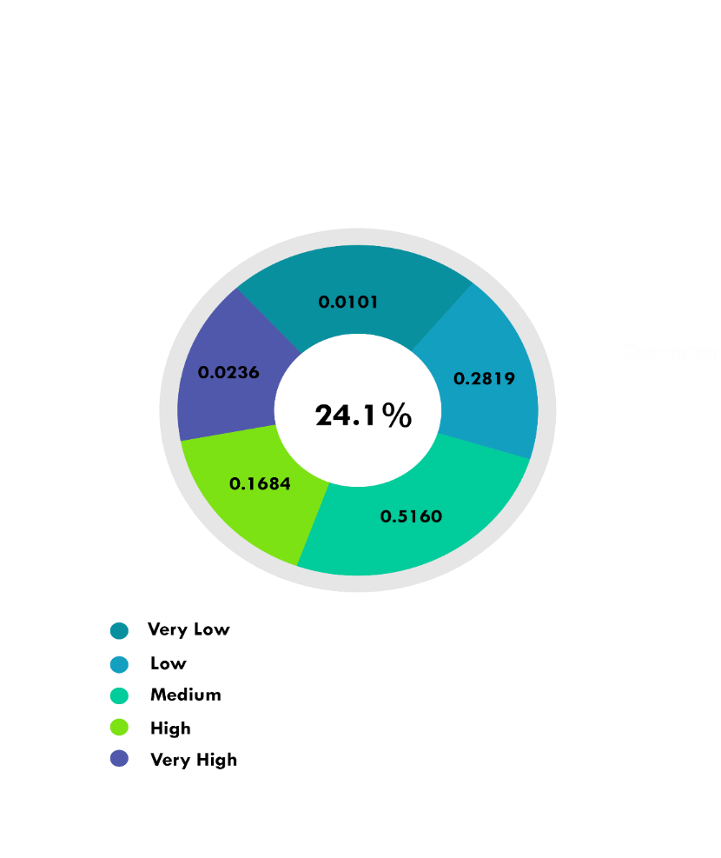

**Figure 5:** The risks level on berth operation at Port “A”.

The recommendations have been made only for the top three risk factors associated with frequency of accident on berth operation (i.e. trailer hit trailer, container slipped and trailer hit worker) are proposed. According to Mansor et al., (2011) mentioned about stress and fatigues are the most factors which contribute accidents (trailer hit trailer) occurred in workplace. These factors may expose the driver trailer on their concentrations in conducting their duties. Therefore, the probability of involving the accidents is high. As this factor may have contributed to these accidents, port authority needs to develop a proper working schedule while operation. Holden et al., (2010) interrupted that, hours expected to work play a significant role in the association between health and work performance. Furthermore, management of port must to ensure they are no worker that works too long after their usual schedule of working hour.

As mentioned by Shang and Tseng (2010), the terminal operations should control the probability of risks accidents efficiently, especially through staff training. The quay crane operator needs to have the standard certification and equipped them with skill and knowledge before their involved in operations. Further, the worker should be monitored in current situation and performance must be assessed and the maintenance should be maintained regularly. In order to reduce the human error effectively whilst operation, it suggested that, the management require to set a system of rewards and penalties called as pay attention to every risk will occur.

Develop safety in workplace with separate clearly walkways and to prevent pedestrians walking in front of vehicles need to be implement in the port area. Other than that, Health and Safety Authority (2015) made a discussion related to the worker should wear high visibility clothing to make them easier to see by the truck driver especially working during night. Unsafe act needs to be monitored and manage by the port to establish standard policies and procedures such as workers should be fully equipped with personal protective equipment during perform such operation in port.

**6. CONCLUSION**

The purpose of the study focused on the berth operations at Port “A” by using several mathematical methods (i.e. AHP and ER) and decision support framework to be employed to answer the research objectives. For the assessment process, firstly, various risk factors on berth operation are identified. Secondly, generic model is developed in a hierarchal structure. Thirdly, AHP method has been used to establish every criterion. Fourthly, risk factor assessment and finally, an ER algorithm are used to synthesis experts’ judgements and operation on subsets by using IDS software. As a result, there are three most critical risks (i.e. trailer hit trailer, container slipped, and trailer hit worker) contribute to accidents among workers. In order to minimizing these risks and prevent them into zero harm, this study came out with several recommendations which has been discussed from the previous research. This study has provided appropriate risk assessment and the concept of risk management on berth operation at Port “A”. Besides that, it also gives some recommendations to the port authority in order to avoid frequency and severity of accidents occurred during operations. study investigated how to mitigate only three top risk factors during in berth operations, further research could expand the scope of the study to investigate the whole risks factors not only on berth operation but also at the whole port operation at other port in the world.

**REFERENCES**

Alyami, H., Yang, Z., Riahi, R., Bonsall, S., & Wang, J. (2016). Advanced uncertainty modelling for container port risk analysis. Accident Analysis & Prevention.

Antão, P., Calderón, M., Puig, M., Michail, A., Wooldridge, C., & Darbra, R. M. (2016). Identification of occupational health, safety, security (OHSS) and environmental performance indicators in port areas. Safety science, 85, 266-275.

Bauk, S.; Šekularac-Ivošević, S.; Jolić, N. 2015. Seaport positioning supported by the combination of some quantitative and qualitative approaches, Transport 30(4): 385–396.

Bauk, S., Schmeink, A., Colomer, J. (2018). An RFID Model for Improving Workers’ Safety at The Seaport in Transitional Environment. *Transport, 33*(2): 353-363.

Chlomoudis, C. I., & Tzannatos, E. S. (2016). Port Risk Assessment Methodology for Human Accidents Container Terminals: Evidence from the Port of Piraeus–Greece. International Journal for Traffic and Transport Engineering, 6(4).

Chang, C. H., Xu, J., & Song, D. P. (2014). An analysis of safety and security risks in container shipping operations: A case study of Taiwan. Safety Science, 63, 168-178.

Cho, I. S., Kim, I. C., & Lee, Y. S. (2010). The Introductory Concept of Maritime Safety Audit as a tool for Identifying Potential Hazards. Journal of Navigation and Port Research, 34(9), 699-704.

Cho, H. S., Lee, J. S., & Moon, H. C. (2018). Maritime risk in seaport operation: A cross-country empirical analysis with theoretical foundations. The Asian Journal of Shipping and Logistics, 34(3), 240-247.

Christou, M.D., 1999. Analysis and control of major accidents from the intermediate temporary storage of dangerous substances in marshalling yards and port areas. Journal of Loss Prevention in the Process Industries 12, 109-119.

Corrigan, S., Kay, A., Ryan, M., Ward, M. E., & Brazil, B. (2019). Human factors and safety culture: Challenges and opportunities for the port environment. Safety Science, 119, 252-265.

Darbra, R.-M.; Casal, J. 2004. Historical analysis of accidents in seaports, Safety Science 42(2): 85–98.

Darbra, R. M., Crawford, J. F. E., Haley, C. W., & Morrison, R. J. (2007). Safety culture and hazard risk perception of Australian and New Zealand maritime pilots. Marine Policy, 31(6), 736-745.

Ding, J. F., & Tseng, W. J. (2012). Applying fuzzy AHP approach to evaluate key operational safety elements for exclusive container terminals of Kaohsiung Port in Taiwan. WSEAS Transactions on Mathematics, 11(10), 855-865.

Fadda, P., Meloni, M., Fancello, G., Pau, M., Medda, A., Pinna, C., & Leban, B. (2015). Multidisciplinary study of biological parameters and fatigue evolution in quay crane operators. Procedia Manufacturing, 3, 3301-3308.

Häkkänen, H., & Summala, H. (2001). Fatal traffic accidents among trailer truck drivers and accident causes as viewed by other truck drivers. Accident Analysis & Prevention, 33(2), 187-196.

Hamka, M. A. (2017). Safety risks assessment on container terminal using hazard identification and risk assessment and fault tree analysis methods. Procedia engineering, 194, 307-314.

Hänninen, M., Banda, O. A. V., & Kujala, P. (2014). Bayesian network model of maritime safety management. Expert Systems with Applications, 41(17), 7837-7846.

Health and safety in engineering workshops. (2004). Sudbury, Suffolk: Health and Safety Executive.

IMO. (2015). IMO Profile: Overview. International Maritime Organization (IMO). Available from Internet: [http://business.un.org/en/entities/13 on 3 Feb 2020](http://business.un.org/en/entities/13%20on%203%20Feb%202020).

IMO, 2010. ISM Code and Guidelines. International Maritime Organization, London.

IMO, 2012. Guide to maritime Security & ISPS Code. International Maritime Organization, London.

Jalonen, R., Salmi, K., 2009. Safety Performance Indicators for maritime safety management. Helsinki University of Technology, Department of Applied Mechanics, http://appmech.tkk.fi/fi/julkaisut/TKK-AM-9.pdf

John, A., Yang, Z., Riahi, R. and Wang, J. (2016) A risk assessment approach to improve the resilience of a seaport system using Bayesian networks. Ocean Engineering, 111, 136-147

John, A., Paraskevadakis, D., Bury, A., Yang, Z., Riahi, R. and Wang, J., 2014, An integrated fuzzy risk assessment for seaport operations. Journal of Safety Science, Vol. 68, pp. 180-194.

Kim, D.K., Pedersen, P.T., Paik, J.K., Kim, H.B., Zhang, X., Kim, M.S., 2013. Safety

guidelines of ultimate hull girder strength for grounded container ships. Safety Science 59, 46–54.

Kontovas, C. A. (2005). Formal safety assessment: critical review and future role. 163p (Doctoral dissertation, Thesis (Naval Archicteture and Marine Engineering)-National Technical University of Athens, Maritime Transport, Athens, Greece).

Kujala, P., Hänninen, M., Arola, T., Ylitalo, J., 2009. Analysis of marine traffic safety in the Gulf of Finland. Reliability Engineering and System Safety 94, 1349-1357.

Kwong, C. K., & Bai, H. (2002). A fuzzy AHP approach to the determination of importance weights of customer requirements in quality function deployment. Journal of intelligent manufacturing, 13(5), 367-377.

Legato, P., & Monaco, M. F. (2004). Human resources management at a marine container terminal. European Journal of Operational Research, 156(3), 769-781.

Lu, C. S., & Tsai, C. L. (2008). The effects of safety climate on vessel accidents in the container shipping context. Accident Analysis & Prevention, 40(2), 594-601.

Lu, C.S., Tsai, C.L., 2010. The effect of safety climate on seafarers’ safety behaviours in container shipping. Accident Analysis and Prevention 42 (6), 1999–2006.

Mansor, N., Zakaria, N. H., & Abdullah, Z. (2011). Understanding common dimensions of workplace accident in Malaysia. Business and Management Review, 1(6), 22-33.

Marlow, P. B. (2010). Maritime security: an update of key issues. Maritime Policy & Management, 37(7), 667-676.

Mazaheri, A., Montewka, J., Nisula, J., & Kujala, P. (2015). Usability of accident and incident reports for evidence-based risk modeling–A case study on ship grounding reports. Safety science, 76, 202-214.

Merrick, J.R.W and Dorp, R.V. (2006), “Speaking the truth in maritime risk assessment,” Risk Analysis, 26(1),223-237.

Mokhtari, K., Ren, J., Roberts, C., & Wang, J. (2011). Application of a generic bow-tie based risk analysis framework on riskanagement of sea ports and offshore terminals. Journal of hazardous materials, 192(2), 465-475.

Navarackas, J. (2017) Port of Klaipeda Risk Assessment Concerning Safety of Marine Operations. The Faculty of Engineering and Science and The Board of Studies for Civil Engineering.

Pallis, P. L. (2017). Port risk management in container terminals. Transportation research procedia, 25(1), 4411-4421.

Pak, J. Y., Yeo, G. T., Oh, S.W., and Yang, Z. (2015). Port safety evaluation from a captain’s perspective: The Korean experience, Safety Sci.,72, 172–181

Park, D. J., Park, S. B., Yang, H. S., & Yim, J. B. (2016). Finding Hazard factors by new risks on maritime safety in korea. The Korean Society of Marine Environment & Safety, 22(3), 278-285.

Planas-Cuchi, E., Montiel, H., Casal, J., 1997. A survey of the origin, type and consequences of fire accidents in process plants and in the transportation of hazardous material. Trans. IchemE. 75, 3–8.

Planas-Cuchi, E., Vı´lchez, J.A., Pe´rez-Alavedra, F.X., Casal, J., 1998. Effects of fire on a container storage system—a case study. Journal of Loss Prevention in Process Industries 11 (5), 323–331.

Port Skills and Safety, PSS. (2015). Port Industry Accident Statistics

Rekik, I., Elkosantini, S., & Chabchoub, H. (2015). Real-Time Stacking System for dangerous containers in seaport terminals. IFAC-PapersOnLine, 48(3), 141-148.

Roberts, B., and Gray, M. 2013. Improving pedestrian safety in container ports and terminals, Port Technology 59: 40–42.

Rozar, N.M., Razik, M. A., and Sidik, M.H.M. (2018). The Factor Analysis of the Antecedents of Dry Bulk Terminal for Port Operation improvement in Malaysia. *International Journal of Engineering and Technology (IJET)*, 10(6): 1804-1808.

Salleh, N. H. M. (2015). Strategic Risk and Reliability Assessment in the Container Liner Shipping Industry under High Uncertainties (Doctoral dissertation, Liverpool John Moores University).

Salleh N.H.M., Riahi, R. Yang, Z and Wang, J. (2014). Vulnerability, Uncertainty, and Risk: Quantification, Mitigation, and Management - Proceedings of the 2nd International Conference on Vulnerability and Risk Analysis and Management, ICVRAM 2014 and the 6th International Symposium on Uncertainty Modelling and Analysis, ISUMA 20142014, Pages 2320-2329.

Shang, K. C., and Tseng, W. J. (2010). A risk analysis of stevedoring operations in seaport container terminals. Journal of Marine Science and Technology, 18(2), 201-210.

Sidik, M. H., AB Hamid, M.R., Ibrahim, A. and Ali, Z.M. Theoretical Support for Staff Satisfaction in Higher Education Institutions: A Conceptual Framework. *Journal of Quality Measurement and Analysis, 13*(2), 1-18.

Smith, A. P. (2003). Seafarers' fatigue, health and safety. Personalführung, 2, 46-52.

Spanco. (2014). Overhead Crane Safety: Three Major Hazards and Preventative Measures. Retrieved from https://www.spanco.com/overhead-crane-safety-three-major-hazards-preventative-measures/. Accessed date: 10th December 2017.

Tadic, D., Aleksic, A., Popovic, P., Arsovski, S., Castelli, A., Joksimovic, D., & Stefanovic, M. (2017). The evaluation and enhancement of quality, environmental protection and seaport safety by using FAHP. Natural Hazards and Earth System Sciences, 17(2), 261.

Trbojevic, V. and Carr, B. 2000. Risk based methodology for safety improvements in ports. Journal of Hazardous Materials 71, pp. 467–480.

Trbojevic, V. M. (2001). Linking risk assessment of marine operations to safety management in ports. In 6th Biennial Marine Transportation System Research and Technology Coordination Conference, Washington DC (pp. 14-16).

Tseng, P. H., & Pilcher, N. (2012) Exploring the Causes of Port Accidents: A Case Study of Kaohsiung Port, Taiwan.

Uğurlu, Ö. Yıldırım, U., & Başar, E. (2015). Analysis of grounding accidents caused by human error. Journal of Marine Science and Technology, 23(5), 748-760.

Yang, J. B., & Xu, D. L. (2002). On the evidential reasoning algorithm for multiple attribute decision analysis under uncertainty. IEEE Transactions on Systems, Man, and Cybernetics-Part A: Systems and Humans, 32(3), 289-304.

Yip, T. L. (2008). Port traffic risks–A study of accidents in Hong Kong waters. Transportation research part E: logistics and transportation review, 44(5), 921-931.